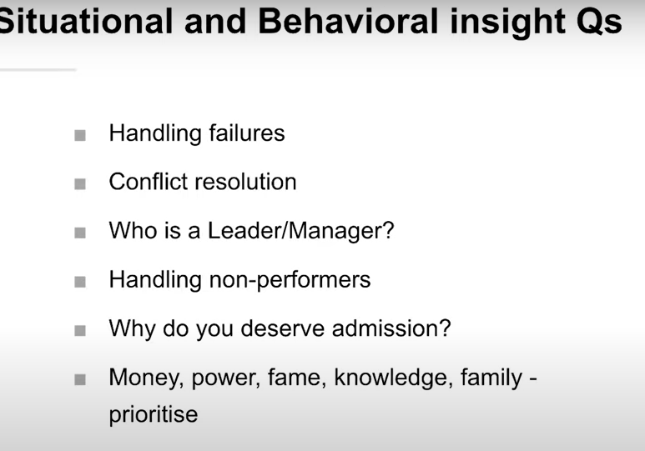

LONG TERM GOAL
When my father joined the Indian Army back in 1992, he was the first person in the entire village to get a government job. He wasn’t really satistified with where he was so he decided to change things for himself. He got commissioned into the Indian Army as an officer. My father dreams of returning to the village and post-retirement and encourage the youths that it is possible to achieve what your dreams are. He wants to open a vocational training school for the youth in his village and act as a mentor and guide them through the various exams. The training school will be a nurturance academy to help them achieve their dreams. This will be step towards their sustainable development. In the long run, I would like to contribute to this dream of his in some way possible with the help of my technical and management skills.

Good ANSWERS
Name an instance where you wanted something and went out of your comfort zone to achieve it? OR Tell us the biggest risk you have taken so far in your life.
The biggest challenge that I had faced was transferring to 4 different cities since my childhood and were Kanpur, Gurugram, Shahjahanpur, and Vindhyanagar and 2 changes were at 9th and 11th classes where I had to follow different pressurized schedules managing parallel with the coaching that tested my patience up to an extreme level.The constant requirement to adjust to new environments and exposure to new cultures taught me to find joy in facing new challenges and learning from failure and that develops adaptability and never gives up approach in me. My parents guidance helped me in gaining and following ethical values and my observation added to the continuous growth that helped me in building my self-confidence and motivated me to do better and follow the right path in life which shaped me as an individual.
Any Other Comments or Factors You Would Like To Highlight About Yourself?
Answer 1 - I have always been a bright and active student with an interest in both academics and co-curricular. My parents have always motivated me and inspired me to study hard and excel in academics. I have been awarded by Deans Merit List in both XLRI and IIIT Allahabad in terms of academics. I was also the Gold Medallist in my UG for scoring the highest CQPI in ECE. Apart from this, I was one of the finalists for the all-round excellence award out of 350+ students. While schooling, I was consistently in the top 3 of my class and received a CBSE Merit Certificate in class 12 for outstanding performance. I also show interest in sports, where I have won Golds in Squash and Basketball along with Bronze in Badminton at the inter-college level. At XLRI, I feel proud to represent the HR dept in the cricket tournament. I have also held many important positions of responsibility, including treasurer of the only Industrial Relation committee in India and the head of Events in the Annual Technical Festival of my college. Having a one-year work experience in the IT sector with Citi, I was complimented by Citi Gratitude Award for showing excellence in teamwork and designing innovative solutions. Before this, I interned with the same company and received PPO for outstanding performance.
Answer 2: Placement Coordinator, SPJIMR (Present): Elected Head of Marketing placement team | Responsible for placements of 238 students of PGDMNational Winner, P&G CEO Challenge (2021): Stood 1/570 teams | Represented India at IMEA Regional FinalsNovartis Biotechnology Leadership Camp (2021): Selected to Novartis Biotechnology Leadership Camp | Among 48 selected out of 1700+ applicantsDare2Compete Awards (2021): Ranked among Top 10 College Champions of SPJIMR for performance across business competitionsScriptwriter and Actor, GASP'21 (Theatre): Conceptualized, penned, and acted in the play 'Crossroads' for the SPJIMR in-house theatre productionHPAIR Asia Conference (2015): Delegate at Harvard Project for Asian and International Relations Conference, Entrepreneurship PanelCofounder, TIP - BITS Goa (2016): Led a team of 15 to mentor 800+ students in projects | Organization has impacted 2000+ studentsCore Member, Nirmaan Org. (NGO) (2015): Part of Notebook Project, donated refurbished notebooks | Helped organize Joy of Giving WeekResearch Paper Publication in Journal of Cleaner Production: Garnered 15+ citations | Developed process designs for converting biogas to methanol (https://www.sciencedirect.com/science/article/abs/pii/S0959652619301908)All India Rank, GATE: Secured All India Rank 393 out of 14542 candidates in GATE 2017, Chemical Engineering ExamKPMG Green Belt Lean Six Sigma (2015): Completed requirement of Green Belt in Lean Six Sigma Methodology
Answer 3 : Received Direct Shortlist Pass for PPSI out of 1800 applicants for P&G Summer Internship 2021 (2020)Winner of the Smart India Hackathon 2019 Software Edition organised by Ministry of HRD India (2019)Published research paper in IEEE journal & presented it in 4th International Conference on Electronics & Informatics trends (2020)Bagged a Scholarship by Maharashtra State Board for being in the Top 1% of students in the HSC exam (2016)Awarded Certificate of Merit from CBSE for outstanding performance in Class 10 board exam (2014)Secured 146th rank at International level in 15th National Science Olympiad conducted by SOF (2012)Attained AIR-6 in the Annual All India United Nations Information Test consecutively for 2 years (2009)Secured 6th Position at National Level in Annual All-India General Knowledge Test conducted by USO (2010)Scored 99.99 Percentile at State Level in the Maharashtra State Council Scholarship Examination (2008)

When was the last time someone relied on you? OR What did you do which was purely for someone else - a truly selfless act.
I think the one selfless act that I can think of which stays close to me even though it was something that happened in 10th grade was when I didn't help my friend in the middle of an ongoing exam. To add more context to it, it was the Math pre-boards and this friend of mine wanted my help in the middle of the exam to solve a question. I chose not to help him because in principle I do not believe in the idea of cheating in any form. After the exam, my friend told me that he was angry and he was worried that he might not get his Boards admit card from the school if he didn't clear the marks cut-off we had in our school. I assured him that this rule is something most likely done by the school to have students prepare well for the Boards. My friend was still angry that I didn't help him during the exam. However, after the exam for the next few days, I sat down with him and tried to convince him to let me teach him Math for boards so that when the real exam comes up, he is able to do well. I would sit with him during recess and explain concepts from algebra, geometry, etc. and make him solve problems, and guide him if he got stuck. My friend eventually improved and got more confident with the subject. He started doing the problems and past year question papers well. Finally, he ended up scoring really good marks in the actual Board exam. After the results, he did reach out to me in person and thanked me for the help and for not telling him the answer in that Math pre-board exam. I believe this is a selfless act that has stuck with me and has always helped me keep myself and those around me on the right path in life. I cannot actually call it a selfless act because it has given me valuable learning that of effort and hard-work yielding results.

My ambition for my next 5 years post my MBA is to be exposed to a diverse set of problems from different domains and post that I would use this learning to perhaps start a venture of my own after having identified a set of problems that I wish to tackle in a particular domain.
Could go into my experience of organising anything : I had to reshape my comfort zone because the task at hand required a lot of attention to detail, and coordination and synergy among the team members - something that I had to ensure as the overall head. So, I led the different verticals to start working in their domains. I had to sit and brainstorm plans with each vertical.
At the same time, we were reaching out to alums through the webmail but a pass out does not check the webmail very often, so the leads initially were very low. Then I recommended the team for reaching out to the alumni through social media platforms like LinkedIn and Facebook. This switch was risky as these platforms are personalized and not suitable for conducting such official communications. But, due to this switch, we were able to boost the connections and network significantly. Evetually this lead to a great success.
Now looking back at my journey till now, I feel I would not have been able to make it this far had I not taken that decision back then. I believe that was a key decision which I took in my life which turned out well. Studying with better talented peers invoked competitiveness in me and helped me to dream high. I could get placed at Mu Sigma from CET, and my life there prepared me to pursue MBA.

Best decision that you took?
During my work experience as a Data Analyst with JLL Technologies, I led a team working on a critical project. Our leadership team was continuously monitoring the updates as it was a pilot project. Before I had joined the team, they had tried a few methods that did not work well. Almost at the same time, there was a change in the reporting manager as well. I quickly took hold of the project and started exploring new ways to achieve the objectives. I was able to come up with a few approaches that we could potentially try out. However, the new manager insisted on following the whole data process as it is. I, on the other hand, was sure that applying the new method was the immediate next step based on my understanding of the data and the results of previous attempts. Due to my manager's reluctance to proceed with my idea, I took it up as a challenge. I pitched my idea with the leadership team in the next meeting. I had prepared well and I was able to effectively answer all concerns raised in the meeting. Thus, I could convince our senior management team about my approach. Later, the management head decided to proceed with my approach to streamline the process. We worked hard as a team to execute the idea with the help of other data analysts. The results of the change were promising and the team was very happy with the results, asking us to expand our approach to a few other domains as well. Thus, we improved upon the data requirements by the project by more than half, thus reducing the overall billing on the project.

Business Analytics is all about driving insights through mining and playing around with data using which companies can make informed decisions. Presenting the right information in the right way is also a key skill required for a Business Analyst. Dashboards help to narrate stories from data in a presentable way. I was able to learn and get hands-on experience on multiple dashboarding tools like DOMO, PowerBI, Spotfire and Tableau. I could execute analytics projects with numerous Fortune 500 firms using these tools. I was also invited as a speaker to an Organisation-wide session on Dashboarding using Spotfire. That was an excellent platform for me to share my learnings with my peers through a hands-on working session.I often wondered, What is Machine Learning? when I read about the topic in newspapers and online articles. Being a Mechanical Engineer by education, the term was very unfamiliar to me. I learnt the basics of Machine Learning from the training sessions at Mu Sigma. I used my time outside office hours to read up on online material and do mock projects. I also took courses with the internal Mu Sigma university to learn from experts in the firm. All these efforts became fruitful while working with a US medical device manufacturer on a project to forecast the demand for their transport network. It was a short proof of concept project where we had to showcase our expertise. The project had limited data, and forecasting was required at multiple levels. In two weeks, I had trained and tested 24 ARIMA models to forecast the required metric for the client. The client was delighted by the quick turnaround and high accuracy which their internal teams were not able to achieve. Later, they requested me to take a working session on ARIMA and gave an appreciation note to our team for our proof of concept. Artificial Intelligence is my new area of interest. Extending from my interest in machine learning techniques, I have now begun to learn and explore the field of AI. To quote the words of one of our Professors, AI might not replace managers, But manager knowing AI might replace the managers who don't.

During the release of a project at work, I faced escalation on a few critical issues. A senior team member who had been working on these aspects was on urgent personal leave. On contact, he asked me to delay until he is back by saying that there was no issue from our side. My options were to accept that I was unaware of the problem and ask for time to fix it or do as my senior had said. The latter was ethically wrong from my perspective, but since he was my senior and had given me instructions, I was confused on how to disagree with him. In the meeting, I decided to go ahead and do what I believed was the right decision. I took the details from the business team and asked them for time till the end of the day to check things from my side. I spent the entire day in the office till around 10 PM to understand the code and spotted the issue. I did a quick fix for the same and emailed the business team asking for time to build a permanent and stable solution. I believe that, given a choice, it is always better to do what is ethically right even if others disagree. Last-minute stitches or cover-ups wont put up for long and will end up amplifying the issue.

